**Brooklyn torah gazette**

**For parshas nasso 5781**

Volume 5, Issue 40 (Whole Number 240) 11 Sivan 5781/ May 22, 2021

**Printed L’illuy nishmas Nechama bas R’ Noach, a”h**

For a free subscription, please forward your request to [***keren18@juno.com***](mailto:keren18@juno.com)

Past emails can be found on the website **ShabbosStories.com**

**The Difference Between Building Pyramids as Slaves and Constructing the Sanctuary**

**From the Talks of the Lubavitcher Rebbe**

**Rabbi Menachem Mendel Schneerson, Zt”l**

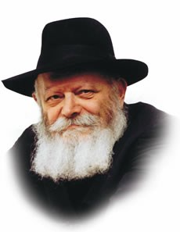

"It came to pass on the day that Moses had finished setting up the Sanctuary..." As we read in this week's Torah portion, Naso, after the Jewish people had finished constructing all of the Sanctuary's different components, they brought them to Moses so that he could erect it. For the massive wooden planks were just too heavy; even working together, the Jews were unable to build the Sanctuary by themselves.

Recognizing the dilemma, Moses asked G-d how human beings could be expected to perform such a difficult task. G-d told him to put his hand on the enormous boards; they rose by themselves, and the Sanctuary was erected in a miraculous manner. But why was it necessary for G-d to perform a miracle?

**Building Treasure Cities for Pharaoh**

According to historians it was the Jewish slaves who built the pyramids in Egypt. Indeed, the Torah tells us, "And they built treasure cities for Pharaoh, Pitom and Raamses." Each individual stone of the pyramids weighed several tons, yet, as depicted in ancient hieroglyphics and paintings, the slaves nonetheless managed to drag these tremendous weights and build the colossal edifices that continue to exist till this very day.

The wooden planks of the Sanctuary weighed far less than these stones. Why then did the Jewish people find it impossible to lift them? Why was it necessary for the Sanctuary to be erected by means of a miracle?

The answer lies in the fact that the pyramids were built by slave labor, by "avodat perach" (back-breaking, rigorous work). The only reason the Jewish slaves were able to move the stones was because Pharaoh compelled them to.

The Jewish people had no choice; they obeyed Pharaoh's commands out of fear. This fear motivated them to tie themselves together with rope (as seen in the paintings) and perform the seemingly superhuman feat.

**A Different Type of Work in Building the Sanctuary**

Building the Sanctuary involved a different type of work entirely. The Sanctuary was to be erected willingly, with joy in being able to execute G-d's command. But the wooden planks proved to be too heavy for the Jews to lift.

G-d didn't want the Sanctuary to be built out of a sense of compulsion. Its erection was a happy event, not a sorrowful one. He therefore made a miracle to express this concept, and the Sanctuary was erected with a feeling of true freedom and liberation.

So it is in the erection of our own individual "Sanctuaries" --- the performance of G-d's mitzvot. Observing G-d's mitzvot should never be considered "back-breaking labor"; rather, we carry out G-d's command willingly, joyfully, and with the full assistance of the Holy One, blessed be He.

*Adapted from a talk of the Rebbe, 5745*

*Reprinted from the 5756/1996 Parshat Nasso edition of L’Chaim Weekly. Adapted from a talk of the Rebbe Rebbe, Vol.4.*

# Rav Avigdor Miller on

# The Test of Discouragement



**QUESTION: You said earlier that the reward, the good things that happen to a righteous person are intended as encouragement for him to continue in his ways. Does that mean that the bad things that happen to righteous people should be considered discouragement?**

**ANSWER:** Yes; but this discouragement that happens to a righteous man is really a form of reward for him because it gives him opportunities to display his love of Hakodosh Boruch Hu.

It’s like a general who wants to see which of his soldiers is really loyal to the country; and so he sees that the ones that are in the thick of the battle – not because they chose it but the battle is thick about them – and there they are fighting with all their might and main in the midst of the difficulties, so he knows that they’re his chosen ones.  The ones who are sitting back in the headquarters at the typewriters, nothing is proven about them.

So Hakodosh Boruch Hu takes His righteous men who He has tested previously with smaller tests and He gives them now bigger tests as a reward for them. And now He gives them decorations for their successes.

That’s why it says (Bereishis 22:1),  And it was after Avraham Avinu passed the previous tests, then Hashem tested him with a very big test. And so, that difficulty, that discouragement that Hashem sends your way, is actually a reward because it’s an opportunity for you to display your loyalty.

*Reprinted from the May 10, 2021 email of Toras Avigdor. Adapted from Tape #16.*

**Parshas Nasso**

**I Never Do Anything Wrong**

**By Rabbi Bentzion Shafier**

**Founder of TheSmuz.com**

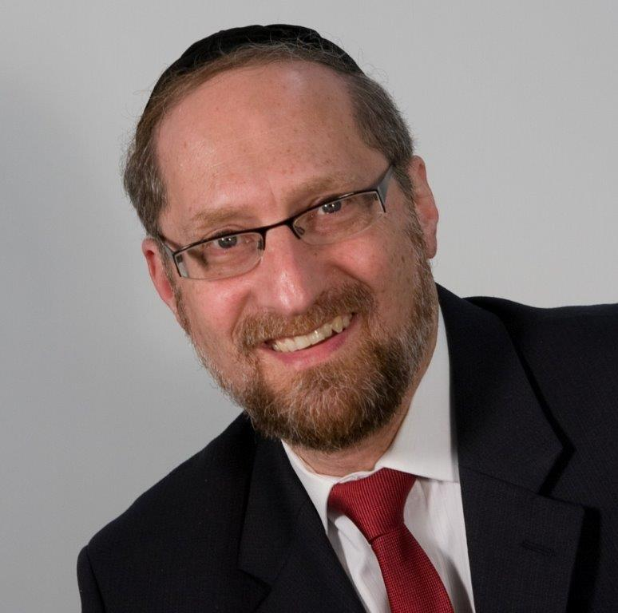

“Speak to the Bnai Yisrael and say to them: any man whose wife shall go astray and commit treachery against him. . . ” — Bamidbar 5:12

**The Parsha of Sotah**

The Torah describes the details of a sotah. If a woman acts in a manner that causes her husband to suspect her of infidelity, he should warn her not to go into seclusion with that other man. If she violates this warning, then the husband is to take her to the Kohain. The Kohain will give her the “bitter waters” to drink. If she was unfaithful, she will instantly die. If she was not unfaithful, she will be redeemed and blessed.

When the Torah lays out the details, it uses an unusual expression: י “If a man will ‘tistheh’ his wife.” The word “tishteh” comes from the root “shoteh,” which means insanity. It’s as if to say, “If a man will accuse his wife of insanity.”

Rashi is troubled by the use of this expression. He explains, based on the Gemara, **adulterers do not sin until a wave of insanity enters them**. The Siftei Chachmim explains this to mean, “until their yetzer harah teaches them it is permitted.”

It seems clear from the Siftei Chachaim that the modus operandi of the yetzer harah is to convince the potential sinners that the act tempting them is permitted. Only when it succeeds, and they are convinced, will they then transgress.

This statement — people only sin when they are convinced that it is permitted — seems difficult to understand. If we are dealing with a pious, proper Jewish woman who got into a bad situation, she knows that the act that she wants to commit is forbidden. How can the yetzer harah teach her that it is permitted? On the other hand, the Torah may be speaking about the opposite extreme — a woman who has gone off the path and just doesn’t care. Why does she need the yetzer harah to tell her it is permitted? She doesn’t care.

So on both sides of the spectrum, the yetzer harah either should not be able to convince the person that it is permitted, or it shouldn’t need to convince them.

**I Never Do Anything Wrong**

The answer to this question is based on understanding one of the most consistent quirks of human nature: Whether dealing with sophisticated adults or schoolchildren, whether Supreme Court justices or convicted felons, the human seems never to do anything wrong. Wardens will tell you that their jails are filled with self-proclaimed innocent men.

Criminals aren’t wrong. Thieves aren’t wrong. Murderers aren’t wrong. You won’t find a gangster proclaiming, “Yes, it is evil to murder and pillage, but what can I do? I am weak and give into my desires.” Instead, you will hear an entire belief system explaining that his approach to life is actually better for society and the world.

The question is why? Why can’t man just admit: it is wrong to steal, but I want to do it anyway?

**The Inner Workings of the Human**

The reason for this has to do with the inner working of the human. HASHEM created man out of two distinct parts. One is comprised all of the drives and passions found in the animal kingdom; it is simply base instincts and desires. The other part of man is pure intellect: holy, good and giving. That part of me wishes to be generous and noble and only aspires for that which is good.

Because this part of me is made up of pure intellect and wisdom, it would never allow me to sin. It sees the results too clearly. It understands that all of HASHEM’s commandments are for my good and that every sin damages me. Because of this crystal clear insight, the human would not have the free will to sin. In theory, he could be tempted to sin, but he would never actually come to the act. It would be akin to sticking his hand in a fire. In theory he could do it, but it would never happen. It’s a dumb thing to do. So if HASHEM created man with just these two parts, man would not have free will in a practical sense.

**Hashem has Allowed Imagination**

To allow man to be tempted so that he can choose his course and be rewarded for his proper choices, HASHEM put another component in man: **imagination**. Imagination is the creative ability to form a mental picture and feel it as vividly **as if it were real**. Armed with an imagination, man can create fanciful worlds at his will and actually believe them.

If man wishes to turn to evil, he can create rationales to make these ways sound noble and proper — and fool himself at least. If he wishes, he can do what is right, or if he wishes, he can turn to wickedness. Even his brilliant intellect won’t prevent him. He is capable of creating entire worldviews that explain how the behavior he desires is righteous, correct, and appropriate. Now man has free will.

**The Power of Rationalizing**

The answer to the Rashi is on two levels. First off, we see the power of rationalizing. Even a fully mature, pious woman who grew up in the best of homes can be convinced, on some level, that illicit relations are permitted. The yetzer harah will use her imagination and create clever and creative ways to explain that black is white, in is out, and arayos is permitted. As ridiculous as it sounds, that is the power given to the yetzer harah.

The second idea is that even the woman who seems to be off the derech and wouldn’t need an excuse really does. No human can ever do something that is wrong. Because of the greatness of her soul and the truth that she knows deep down inside, she understands that for a married woman to go to another man is forbidden. The only way that she can perpetrate this act is if she has a rational way of explaining how in fact it is permitted. The human is incapable of doing something wrong. The only way he can do something wrong is by making it right.

*Reprinted from the website of Theshmuz.com.*

**Rabbi Yitzchak Breitowitz**

**On The Difference Between**

**Shabbos and Yom Tov**

**By Daniel Keren**

(YouTube – ***Rabbi Yitzchak Breitowitz – The Nature of Shabbos and the Counting of the Omer***, 1:07:56)

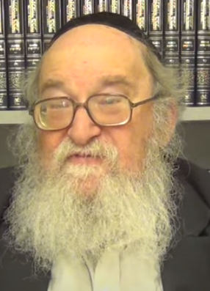

**Rabbi Yitzchak Breitowitz**

One of the most popular Torah lecturers today is Rabbi Yitzchak Breitowitz who obtained his rabbinical semicha (ordination) from the Ner Israel Rabbinical College in Baltimore where he simultaneously earned a bachelor’s degree from John Hopkins University. Afterwards he graduated from Harvard Law School. He practiced law in Chicago and joined the law faculty at the University of Illinois.

While in Chicago, Rabbi Breitowitz met and married Sally Naimon. In the early 1980’s they relocated to Maryland where he joined the faculty of the University of Maryland Law School and became the rabbi of the Woodside Synagogue in Silver Springs, Maryland, a suburb of Washington, D.C.

**The Plight of the Agunah**

Among the many topics Rabbi Breitowitz has written on Jewish law and ethics were his insights on the right to die, physician assisted suicide, brain death, the desecration of ancient burial sites through archaeological excavations, shalom bayis and spousal abuse. Perhaps his Magnus opus is “Between Religious and Secular Law: The Plight of the Agunah [Greenwood Press.]

Rabbi Breitowitz has become a popular Torah lecturer because of the combination of his unique intellectual gifts and sincere piety. In 2010, he and his wife made Aliyah and now live in Yerushalayim, where Rabbi Breitowitz is a Senior Lecturer Yeshiva Ohr Somayach where he teaches hundreds of English-speaking baalei teshuvah from around the world.

**Weekly Hour-Long Torah Lecture Videos**

Thousands of English-speaking Jews also from around the world enjoy viewing Rabbi Breitowitz’s weekly hour-long thoughtful and easy-to-understand Torah lectures. The most recent lecture can be found on YouTube by googling – ***Rabbi Yitzchak Breitowitz – The Nature of Shabbos and the Counting of the Omer***.

What is the connection of the Omer and Shabbos? As most readers know, it is our custom to count the 49 days of Sefirah on the day following the first day of Pesach. What is the purpose of the counting the Sefirah? It is counted in order to connect the Yetziah Mitrayim (the Exodus from Egyptian bondage) to the giving of the Torah by Hashem to the Jewish people on the day we celebrate as Shavuos.

Pesach, according to Rabbi Breitowitz, is symbolic of our freedom from the abuses and cruelties of our enslavement to Pharaoh. Yet, Shavuos and the Jewish people’s acceptance of the Torah at Mount Sinai symbolizes our becoming avodim to Hashem, obligated to both study the Torah and perform the mitzvahs.

**Freedom Alone without Torah is Worthless**

The lesson of counting the Sefirah between Pesach and Shavuos is the knowledge that freedom alone without a purpose such as committing our lives to fulfilling G-d’s Torah is worthless.

Rabbi Breitowitz in the YouTube video discusses the difference between Shabbos where one is prohibited from cooking and Yom Tov where it is permitted for a Jew to cook for his festival needs (assuming that Yom Tov doesn’t all fall on Shabbos.)

Why is there a difference between Shabbos and Yom Tov. Rabbi Breitowitz explains that the holiness of Shabbos comes from G-d who alone created the world, whereas the holiness of Yom Tov such as Pesach comes from the Jewish people and their loyalty to Hashem. Shabbos is a matana (gift) from Hashem to the Jewish people that we received without deserving it; therefore it has a more strictness and we have no permission to cook on Shabbos, unless it is a case of pikuach nefesh (a literal matter of life and death.)

For more insights into this fascinating discussion, google – ***Rabbi Yitzchak Breitowitz – The Nature of Shabbos and the Counting of the Omer***.

*Reprinted from the May 14, 2021 email of The Jewish Connection.*

**A Jewish Community Rises**

**In the Sun-Drenched**

**Turks and Caicos Islands**

**By Rabbi Menachem Posner**

Caribbean archipelago gets its first synagogue and permanent rabbi

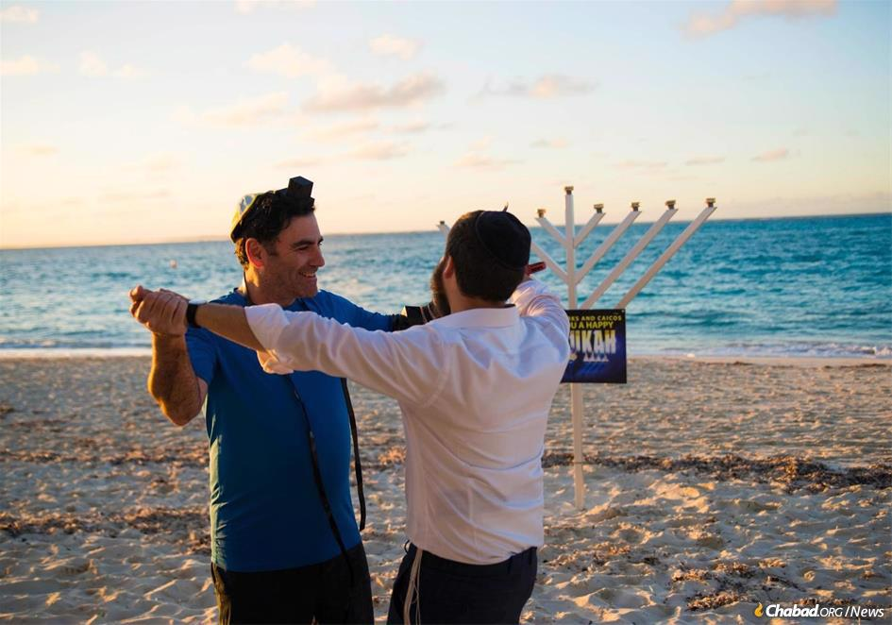

“It is amazing how fast Jewish souls can be ignited,” says the rabbi. “The Jewish pride and Jewish awareness on the island is growing by leaps and bounds.”

When Jill Swann moved to the Caribbean Island of Providenciales to teach windsurfing and sailing, she found just about everything she wanted in Turks and Caicos, an archipelago of 30 islands boasting 230 miles of beach, most of it sprinkled with soft, white sand and surrounded by the sparkling blue waters of the Atlantic Ocean.

Although it was hard for Swann not to fall in love with the place, “there was no Jewish infrastructure and no one to pull the Jews together,” the native of Long Island, N.Y., who has lived on Providenciales—the “gateway” of the Turks and Caicos Islands—for 35 years [tells Chabad.org](http://www.chabad.org/news). “After I adopted my son, I took him to church because I wanted to give him a belief in a higher power.”

Today, much has changed, with Jewish services and community growing in large part due to the warmth and leadership of Rabbi Shmulik and Chaya Berkowitz, who founded the first synagogue and Jewish community center in the archipelago’s history in late 2019, only a few months before the [coronavirus pandemic](http://www.chabad.org/coronavirus) began to spread worldwide.

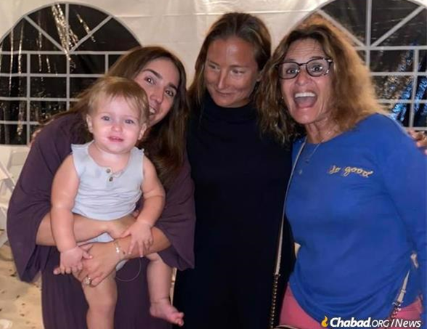

Jill Swann (right) has found Jewish community and celebration at the new Chabad House in Turks and Caicos.

In a villa right off Providenciales’s main thoroughfare, Grace Bay Road, [Chabad of Turks and Caicos Islands](https://www.chabad.org/centers/default_cdo/aid/4564058/jewish/Chabad-of-Turks-and-Caicos-Islands.htm) is easily accessible to guests at the island’s many hotels. “The rabbi and Chaya are so warm and so inviting; people love coming to their home for [Shabbat](https://www.chabad.org/library/article_cdo/aid/253215/jewish/Shabbat.htm) meals or attending services and events,” attests Swann. “I know visitors who have even bought homes on the island to be close to them and participate.”

During the past year, when much of the world was shut down due to the pandemic, Rabbi Berkowitz says they saw steady participation, in part due to North American families who chose to isolate themselves there, attending school and work virtually from the Caribbean.

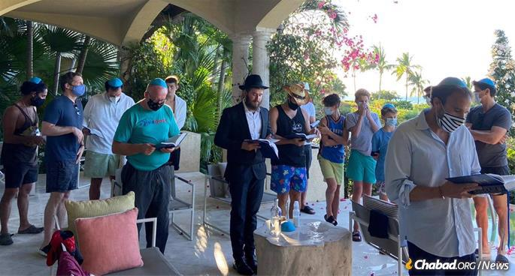

**Balmy weather makes outdoor pandemic-friendly services a cinch.**

All through the winter, the Berkowitzes held outdoor Shabbat services and communal meals, and expect to continue with their regular activities until the island empties for the hurricane season in August.

Having gotten to know more and more locals over the year-and-a-half since they arrived, the Berkowitzes hosted 80 people for the [Passover Seder](https://www.chabad.org/library/article_cdo/aid/253215/jewish/Shabbat.htm) in a giant tent.

Since nearly all food is imported from the United States (the British territory is 600 miles southeast of Miami and uses American currency), there is no shortage of [kosher](http://www.chabad.org/kosher) staples. Meat and dairy, however, have had to be shipped in privately and kept frozen. The rabbi reports that he has arranged for a local supermarket to carry the kosher products and expects [kosher](https://www.chabad.org/library/article_cdo/aid/113424/jewish/Kosher.htm) meat to be on the shelves in a matter of weeks.

During the pandemic lockdowns, the Berkowitzes used the quiet time to get to know people individually and reach out to Jewish islanders and second-home-owners.

To serve the local children as well as those there just for this past winter, the Berkowitzes have held pre-holiday educational events and hope to start a Hebrew school in time for the coming school year.

‘We Knew This Was the Place for Us’

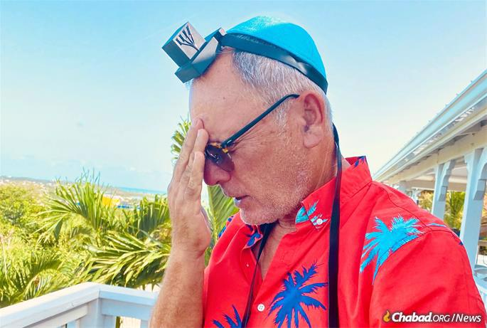

The two both come from families that have served as Chabad-Lubavitch emissaries for generations. Chaya Berkowitz is from Miami, where both her parents and grandparents are emissaries, and the rabbi is from Los Angeles, and would frequently assist Chabad Houses nearby and abroad. After they married in the winter of 2019, they began searching for a place where they could make a difference.

Through Rabbi Mendel Zarchi of [Chabad of Puerto Rico](https://www.chabad.org/centers/default_cdo/aid/118318/jewish/Chabad-Jewish-Center-of-Puerto-Rico.htm), who founded the first permanent [Chabad House](https://www.chabad.org/library/article_cdo/aid/776104/jewish/FAQ.htm) in the Caribbean in 1999, they became acquainted with Turks and Caicos, and flew down for a pilot trip.

Zarchi then connected them with an individual who owns a home in Turks and Caicos and had promised to contribute toward the founding of a [Chabad](https://www.chabad.org/library/article_cdo/aid/244369/jewish/About-Chabad-Lubavitch.htm) presence there. Three weeks after the birth of their child, Shalom Dov Ber, the Berkowitzes moved to Providenciales, just in time to celebrate [Chanukah](http://www.chabad.org/chanukah) 2019.

“We had a big menorah-lighting on the beach, and 100 people showed up,” recalls the rabbi, “and we knew this was the place for us. We were busy every night with lightings in resorts and villas.”

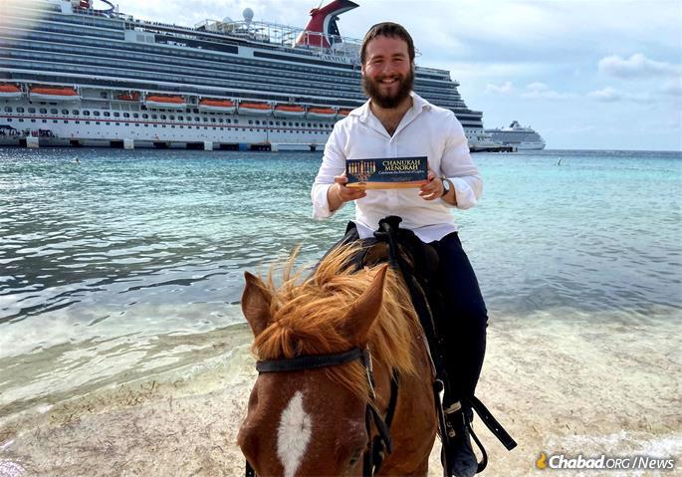

**Rabbi Berkowitz distributing menorahs to cruise ship passengers, a week after his family's arrival.**

With a Torah scroll Zarchi had obtained from the Jaffa Foundation, they began hosting Shabbat services and were planning their first Passover with their new community.

Then the pandemic hit, and they had to halt their operations until the restrictions eased up, but they used the quiet time to get to know people individually and reach out to Jewish islanders and second-home-owners.

“Turks and Caicos is a very small community even by Caribbean standards,” says Zarchi, who has overseen the founding of Chabad centers on 14 islands. “But the Berkowitzes have synergizing different energies that comprise the Jewish experience—primarily the locals, as well as those with second homes, and those who visit briefly to enjoy the beauty of Turks and Caicos—facilitating a fantastic surge of Jewish life.”

The Berkowitzes report that they keep on “finding” more and more local Jewish residents who are excited to learn that they have a center for Jewish worship and celebration on the island. “It is amazing how fast Jewish souls can be ignited,” says the rabbi. “The Jewish pride and Jewish awareness on the island is growing by leaps and bounds.”

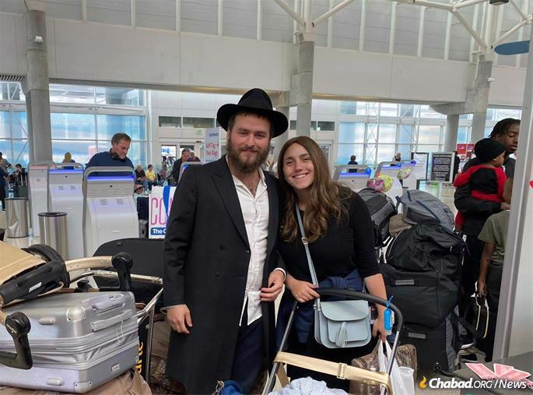

**Three weeks after the birth of their child, Shalom Dov Ber, the Berkowitzes moved to Providenciales, just in time to celebrate Chanukah 2019.**

One indication of how far things have developed is the fact that they are now under contract to purchase a permanent location for their center, which they hope will soon be expanded to include a *mikvah* as well.

“The Berkowitzes reach out to people and make connections,” observes Swann. “I speak for many others when I say that I am very grateful that they are here.”

*Reprinted from the May 11, 2021 dispatch of Chabad.Org News*